Tiger Tales

Kaye M. Breon
Principal
Ann Steger
Assistant Principal
Web Site: http://wfes.hcpss.org/ School Hours: 9:15 a.m. - 3:45 p.m.
West Friendship E.S.
12500 Frederick Road
West Friendship, MD 21794
P: (410) 313-5512
F: (410) 313-5514
February 17, 2017

FROM THE ADMINISTRATORS

Kindergarten registration will begin Monday, February 27 – Friday, March 3, 2017. Please spread the word to friends, neighbors, and family who have a child who will be 5-years old by September 1, 2017. You will find more information within the “School News” section of this newsletter.

Parent/Teacher conferences will be held in March. Information on scheduling conferences will be sent home with students on Thursday, February 23rd. We will be using the Synergy system to schedule conferences. This is the same process we used for fall conferences. The sign-up window opens February 24th at 9:00 a.m. and closes March 3rd at 1:00 p.m. You will receive detailed instructions next week via School Messenger. If you need assistance, please contact Mrs. Colleen Green at 410-313-5512.

Our school photographer, Strawbridge Studios, will be at West Friendship on Thursday, February 23rd to take classroom group pictures and individual spring portraits. Please send your child(ren) to school with their best smiles, as all students will be photographed. The cost of a classroom group picture is $10. Photo envelopes were sent home in today’s Friday Folders and must be returned by February 23rd. All students will pose for individual spring portraits. No payment is needed at this time. A photo package will be sent home in a few weeks for your review. You will then have the opportunity to purchase the complete package or a portion of the package. At that time you will return payment and/or the non-purchased portraits to school. Pictures are a fundraiser and we thank you for your continued support.

Hearing and Vision Screening will take place on March 21st. All Kindergarten and First Grade students will be screened that morning. We will need three parent volunteers from 9:00 a.m. to 12:00 noon. Volunteers will locate students, walk them to and from the screening area, and supervise them as they wait to be screened. If you are able to help us, please contact Ms. Penny Jones at Penny_Jones@hcpss.org or 410-313-5512.

This is a reminder that schools are closed on Monday for Presidents’ Day and closed to students on Tuesday, as staff will participate in a Countywide Professional Learning Day. We hope you enjoy the long holiday weekend with your family.

Sincerely,

Kaye M. Breon, Principal
Ann Steger, Assistant Principal

CALENDAR OF EVENTS

Monday, February 20 Schools Closed for Presidents’ Day
Tuesday, February 21 Schools Closed for Students – Professional Learning Day
Thursday, February 23 Class/Group Photos & Individual Spring Portraits
Thursday, February 23 Grade 4 NAEP Testing
Friday, February 24 Parents May Begin to Schedule Parent/Teacher Conferences
Wednesday, March 8 Interim Reports Issued
Thursday, March 9 Parent/Teacher Conferences – 3-Hour Early Dismissal
Friday, March 10 3-Hour Early Dismissal (12:45 p.m.)
Friday, March 10 PBIS Celebration - 9:30 to 10:30 a.m.

SCHOOL NEWS

Kindergarten Registration – February 27th through March 3rd
Do you have a child who will be 5-years old by September 1, 2017? Every child who is 5 years old by September 1 must be enrolled in kindergarten this fall or have an approved waiver. Kindergarten Registration Kickoff begins Monday, February 27 - Friday, March 3, 2017, 10:00 a.m. to 3:00 p.m. Students must be registered by their custodial parent (biological, adoptive, legal guardian), and the parent must live within the school attendance area. Please be prepared to spend about 30-minutes completing paperwork. The following documents are required at time of registration:
- Parent picture ID: original driver’s license, military ID, or passport.
- Signed original, current lease or deed with your address, valid dates, signatures.
- Current utility bill with name and address (non-cellular telephone, gas and electric, cable bill).
- Student’s proof of birth (original birth certificate, passport/visa, physician’s certificate, baptismal or church certificate, parent’s affidavit or birth registration).
- Proof of parental relationship, custody, or guardianship. If applicable, bring legal proof of custody (court order).
- Student’s current proof of immunizations signed by a doctor, health care provider, day care provider or school official.
- Documentation of Special Education (IEP), 504, Psychological Report, or related services.
- Any additional paperwork that may be necessary due to special living arrangements or circumstances.
No appointment is necessary during the Kindergarten Registration Kickoff week. If you are unable to register your child during the specified times, please contact Mrs. Colleen Green at 410-313-5512 or colleen_green@hcpss.org to schedule an appointment. Please visit http://www.hcpss.org/enroll/ for additional information.

Spring Portraits & Class Group Photos
Our school photographer, Strawbridge Studios, will be at WFES next Thursday, February 23rd to take classroom group pictures and individual spring portraits. Please send your child(dren) to school with their best smiles, as all students will be photographed. The cost of a classroom group picture is $10. Photo envelopes were sent home in today’s Friday Folders and must be returned by February 23rd. All students will pose for individual spring portraits. No payment is needed at this time. A photo package will be sent home in a few weeks for your review. You will then have the opportunity to purchase the entire package or a portion of the package. At that time you will return payment and/or the non-purchased portraits to school. Pictures are a school fundraiser and we thank you for your continued support.

Cough Drop Reminder from the Health Room
Students may have non-mentholated cough drops (Hall's Breezer's or Luden's) in school ONLY with a parent/guardian note. They may have up to 3 cough drops per day for up to 5 days. After the 5th day we will require a new note. The remaining cough drops can be retrieved from the Health Room, or they will be discarded. Mentholated cough drops are considered a medication and require a doctor’s order. The order form is available at: http://www.hcpss.org/f/aboutus/medform_physorder.pdf
Please contact the Health Room at 410-313-5515 if you have any questions.

School Counselor Intern
My name is Stephanie Wilcom and I am finishing my Master's Degree in School Counseling at McDaniel College. This semester I am fulfilling my internship requirement here at West Friendship Elementary with Mrs. Carita Carlyle, the school counselor. I will be at the school on Tuesdays, Wednesdays, and Thursdays. I am looking forward to getting to know the families here at West Friendship.

Nutrition Information
For the nutrition information shared at Family Fit Night, please go to www.FIT2Order.com.

Access to eBooks Just Got Easier!
The media department added a feature to improve students' access to eBooks. Please try the following steps:
- Have your child log into www.hcpss.me with the username and password s/he uses at school.
- Select the MackinVia button and choose West Friendship Elementary from the drop down menu.
- At the top of the MackinVia screen, you should see a button called "Capstone." Click the button and select the book to play.

These eBooks are read by actors and are very engaging. There are 46 titles to read and enjoy! If you have questions, contact Mrs. Petrilla at Amy_Petrilla@hcpss.org.

Parent Volunteer Information
Thank you for your interest in volunteering at West Friendship Elementary! We value our volunteers and the contributions they make to our students and staff.

According to HCPSS Board Policy, all parent volunteers must complete a Confidentiality Training Course about protecting the privacy of our students, staff, and schools, as well as a Child Abuse and Neglect Training. Please complete these courses before volunteering or chaperoning field trips. The courses take a few minutes to complete. To complete your training courses please visit http://www.hcpss.org/parents/volunteer-information/.

PTA NEWS
Restaurant Fundraiser
When you dine at Glory Days Grill (Ellicott City or Eldersburg locations) now through June 2, 2017, the restaurant will contribute 10% of your total food and beverage purchases to West Friendship Elementary School. Please share this information with your neighbors, friends, and relatives, because the 10% applies to the total food and beverage bill. Simply ask your server for your itemized original receipt and send it to school with your child addressed ATTENTION: PTA/Jen Lowther/Glory Days. Questions? Please mail Jen @ jlowther4@gmail.com.

The Valentine Dance
Thank you to all who came out for the Valentine’s dance! We had a packed house, and all the kids seemed to have a fabulous time dancing the night away. These events are not successful without all of the amazing people who both, a volunteer and attend, we appreciate you!
Here is a photo of the attendees doing the school dance to close out the night.

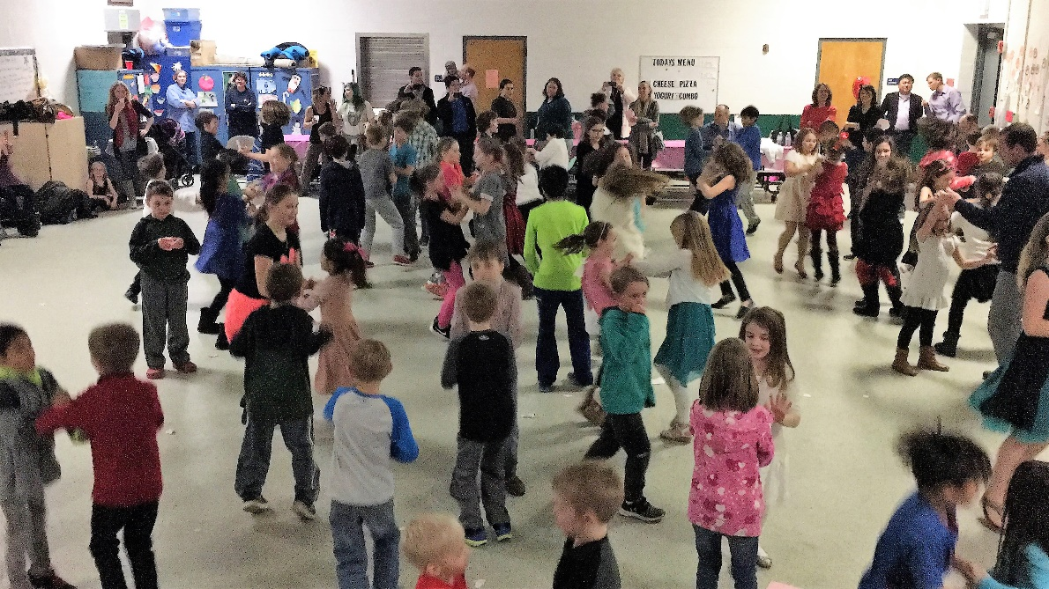

Box Tops Update
A big thanks to all the students and their families who have been collecting and submitting Box Tops during this school year. Each Box Top earns the school 10 cents. So far WFES has earned almost $900, which as always, is put to good use for the betterment of our school! Also, thank you to volunteer mom, Julie Bennett for coordinating the collection and submission of the box tops on behalf of our school!
Please note: The next collection drive will be announced soon, so keep on clipping and saving those Box Tops for next time…every little bit adds up!

Come, Join Us!
The PTA has started planning for next year and we have executive board positions and committee head positions that will need to be filled. If you are interested in getting more involved in the PTA and helping our staff, students, and community have a great year, we would love to hear from you!

Please contact a member of the nominating committee:
Hina Naseem at hnaseem@mac.com
Penny Jones at penny_jones@hcpss.org
Kathy Baur at kdbaur@gmail.com

Checkmate, Mates! Chess Club at WFES
WFES PTA is happy to partner with Silver Knights Chess players and educators to offer a Chess Club at our school. The weekly sessions, beginning in April, will be a mix of learning and play.

Research shows that chess can dramatically improve elementary students’ levels of concentration, boost problem-solving skills and develop their thought processes. It is also believed that chess can boost mathematical literacy levels with amazing benefits across other subjects, including reading — all while having fun!

The WFES Chess Club will be taught by experienced trainers using a curriculum developed by National Masters. Silver Knights also has a need-based scholarship program to help children participate in their program. Classes will be held on Fridays, April 21st to June 9th at 4:00 pm-5:00 pm, except May 19th (school closed for a professional day). The cost for the 7-week session is $98. Find out more at: www.skenrichment.com. You can register your child online at:
https://skenrichment.com/clubs/howard/product/3989-west-friendship-elementary-school-spring-2017.html. Flyers will be sent home next week, and registration ends on April 14th.

Spirit Wear Online Store
Both the t-shirts and the hoodies are available to be purchased online at the WFES PTA website: www.wfespta.com/shop. We have all sizes -- all the way from youth small to adult 3XL!
Order online today and The WFES PTA will send them home promptly via backpack mail.

COMMUNITY NEWS
Learning Together Program
Bushy Park Regional Early Childhood Center-Preschool/Pre-Kindergarten
The Bushy Park Regional Early Childhood Center (RECC) preschool and pre-kindergarten programs are now accepting applications for classes for the 2017/18 school year. These classes include children with and without disabilities. The program’s focus is helping all children develop communication, literacy, math, problem solving, motor, and social skills. Parents of children who will be 3-years old by September 1, 2017 or 4-years of age may contact Katie Hereth in the school office for an application package beginning mid-February.

All applications must be returned by the last Friday in March. A limited number of openings are available for children without disabilities. Children are selected based upon screening information given on the application form and the “Ages and Stages Questionnaire,” as well as observations of the child’s participation in a playgroup on April 7, 2017 from 10-10:30 a.m. If necessary, a lottery process is conducted.

If you have any questions, please contact Katie Hereth at (410) 442-2448 or (410) 313-5500.

Mustang Flea Market – Saturday, February 25
8:00am - 1:00pm • Marriotts Ridge High School Cafeteria • 12100 Woodford Dr • Marriottsville, MD 21104
$1.00 donation per person upon entry. Cash only sales and no early birds, please! Refreshments are available. In case of inclement weather check http://www.mrhsmusic.net for details.
Donations are need! Gently used items can be dropped off at the storage units in the parking lot next to the cafeteria at the following times:
- Saturday, February 18, 9 am to 12 pm
- Friday, February 24, 4pm to 8pm
Please hold approved large items (e.g., furniture, etc.) until Friday, February 24, 4pm to 8pm. Please drop them off in the Commons. Donation receipts available upon request.

Howard County Public Library – Glenwood Branch
The following presentations require registration (which begins one week prior to class). Please register by phone (410-313-5579) or on-line, www.hclibrary.org.

Star Wars STEM Force
Date: Saturday, February 18, 2017
Time: 3:00 PM - 3:45 PM
Description: May the force be with you as you use science, technology, engineering, and math to solve problems and build an Ewok catapult.
Ages 6-9, 45-minutes
*Registration is required online or by calling 410-313-5579.

Book Bingo
Date: Tuesday, February 21, 2017 (Howard County Schools are closed)
Time: 10:30 AM - 11:30 AM
Description: Play Bingo featuring book characters, and maybe win a book!
Ages 5-10; 45-60 minutes
*Registration is required online or by calling 410-313-5579.

A Short Stack of Stories
Date: Tuesday, February 21, 2017
Time: 10:30 AM - 11:00 AM
Description: Celebrate National Pancake Week with stories and activities about this tasty breakfast food.
Ages 3-5; 30-minutes
*Registration is required online or by calling 410-313-5579.

Star Wars STEM Force
Date: Tuesday, February 21, 2017
Time: 3:00 PM - 3:45 PM
Description: May the force be with you as you use science, technology, engineering, and math to solve problems and build an Ewok catapult.
Ages 6-9, 45-minutes
*Registration is required online or by calling 410-313-5579.

Storybook Friends
Date: February 22: Pete the Cat
Time: 10:30 AM - 11:00 AM
Description: A story and craft to enjoy with your child.
Ages 2-5 with adult; 30-minutes
*Registration is required online or by calling 410-313-5579.

Celestial Searchers Young Astronomers Club
Date: Monday, February 27, 2017
Time: 7:00 PM - 8:00 PM
Description: Local astronomy educator Dr. Joel Goodman discusses our solar system and beyond, with engaging hands-on activities. Explore a different astronomy theme each month.
Grades K-8 with adult; 60-minutes
No registration required.

Big Top Twist & Shout
Date: Tuesday, February 28, 2017
Time: 10:30 AM - 11:00 AM
Description: Circus-themed music and movement activities.
Ages 2-5; 30-minutes
*Registration is required online or by calling 410-313-5579.

