Tiger Tales

Kaye M. Breon
Principal
Ann Steger
Assistant Principal
Web Site: http://wfes.hcpss.org/ School Hours: 9:15 a.m. - 3:45 p.m.
West Friendship E.S.
12500 Frederick Road
West Friendship, MD 21794
P: (410) 313-5512
F: (410) 313-5514
March 3, 2017

FROM THE ADMINISTRATORS

Spring is coming! Kindergarten registration has opened, interim progress reports will be coming home on Wednesday, March 8th, parent/teacher conferences begin on March 9th, Junior Achievement Day will be held March 20th, and Family Reading Night on March 29th. There is so much going on at WFES!

Calling all parent volunteers! On March 20th our students will spend the day learning about financial literacy through a daylong activity based program. We need parents who are willing to conduct some of the lessons. Lessons and activities are provided for you, but we need your help in delivering the lessons to our students. If you are available to help and would like more information, please contact Ms. Hina Naseem at hnaseem@mac.com.

A number of parent volunteer opportunities are available in the coming weeks. According to HCPSS Board Policy, all parent volunteers must complete a Confidentiality Training Course about protecting the privacy of our students, staff, and schools, as well as a Child Abuse and Neglect Training. If you have not already done so, please complete these courses before volunteering or chaperoning field trips. The courses take just a few minutes to complete. To complete your training courses please visit http://www.hcpss.org/parents/volunteer-information/.

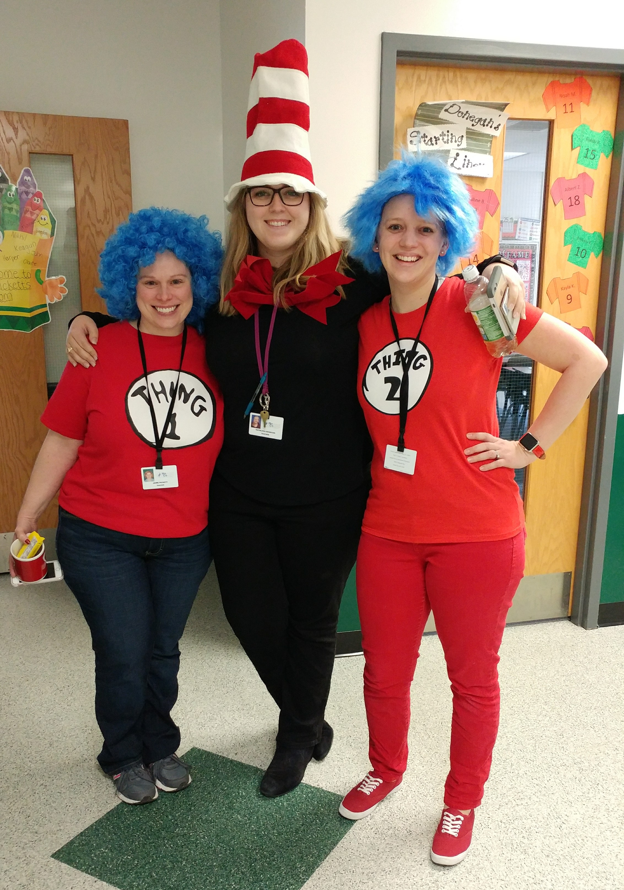
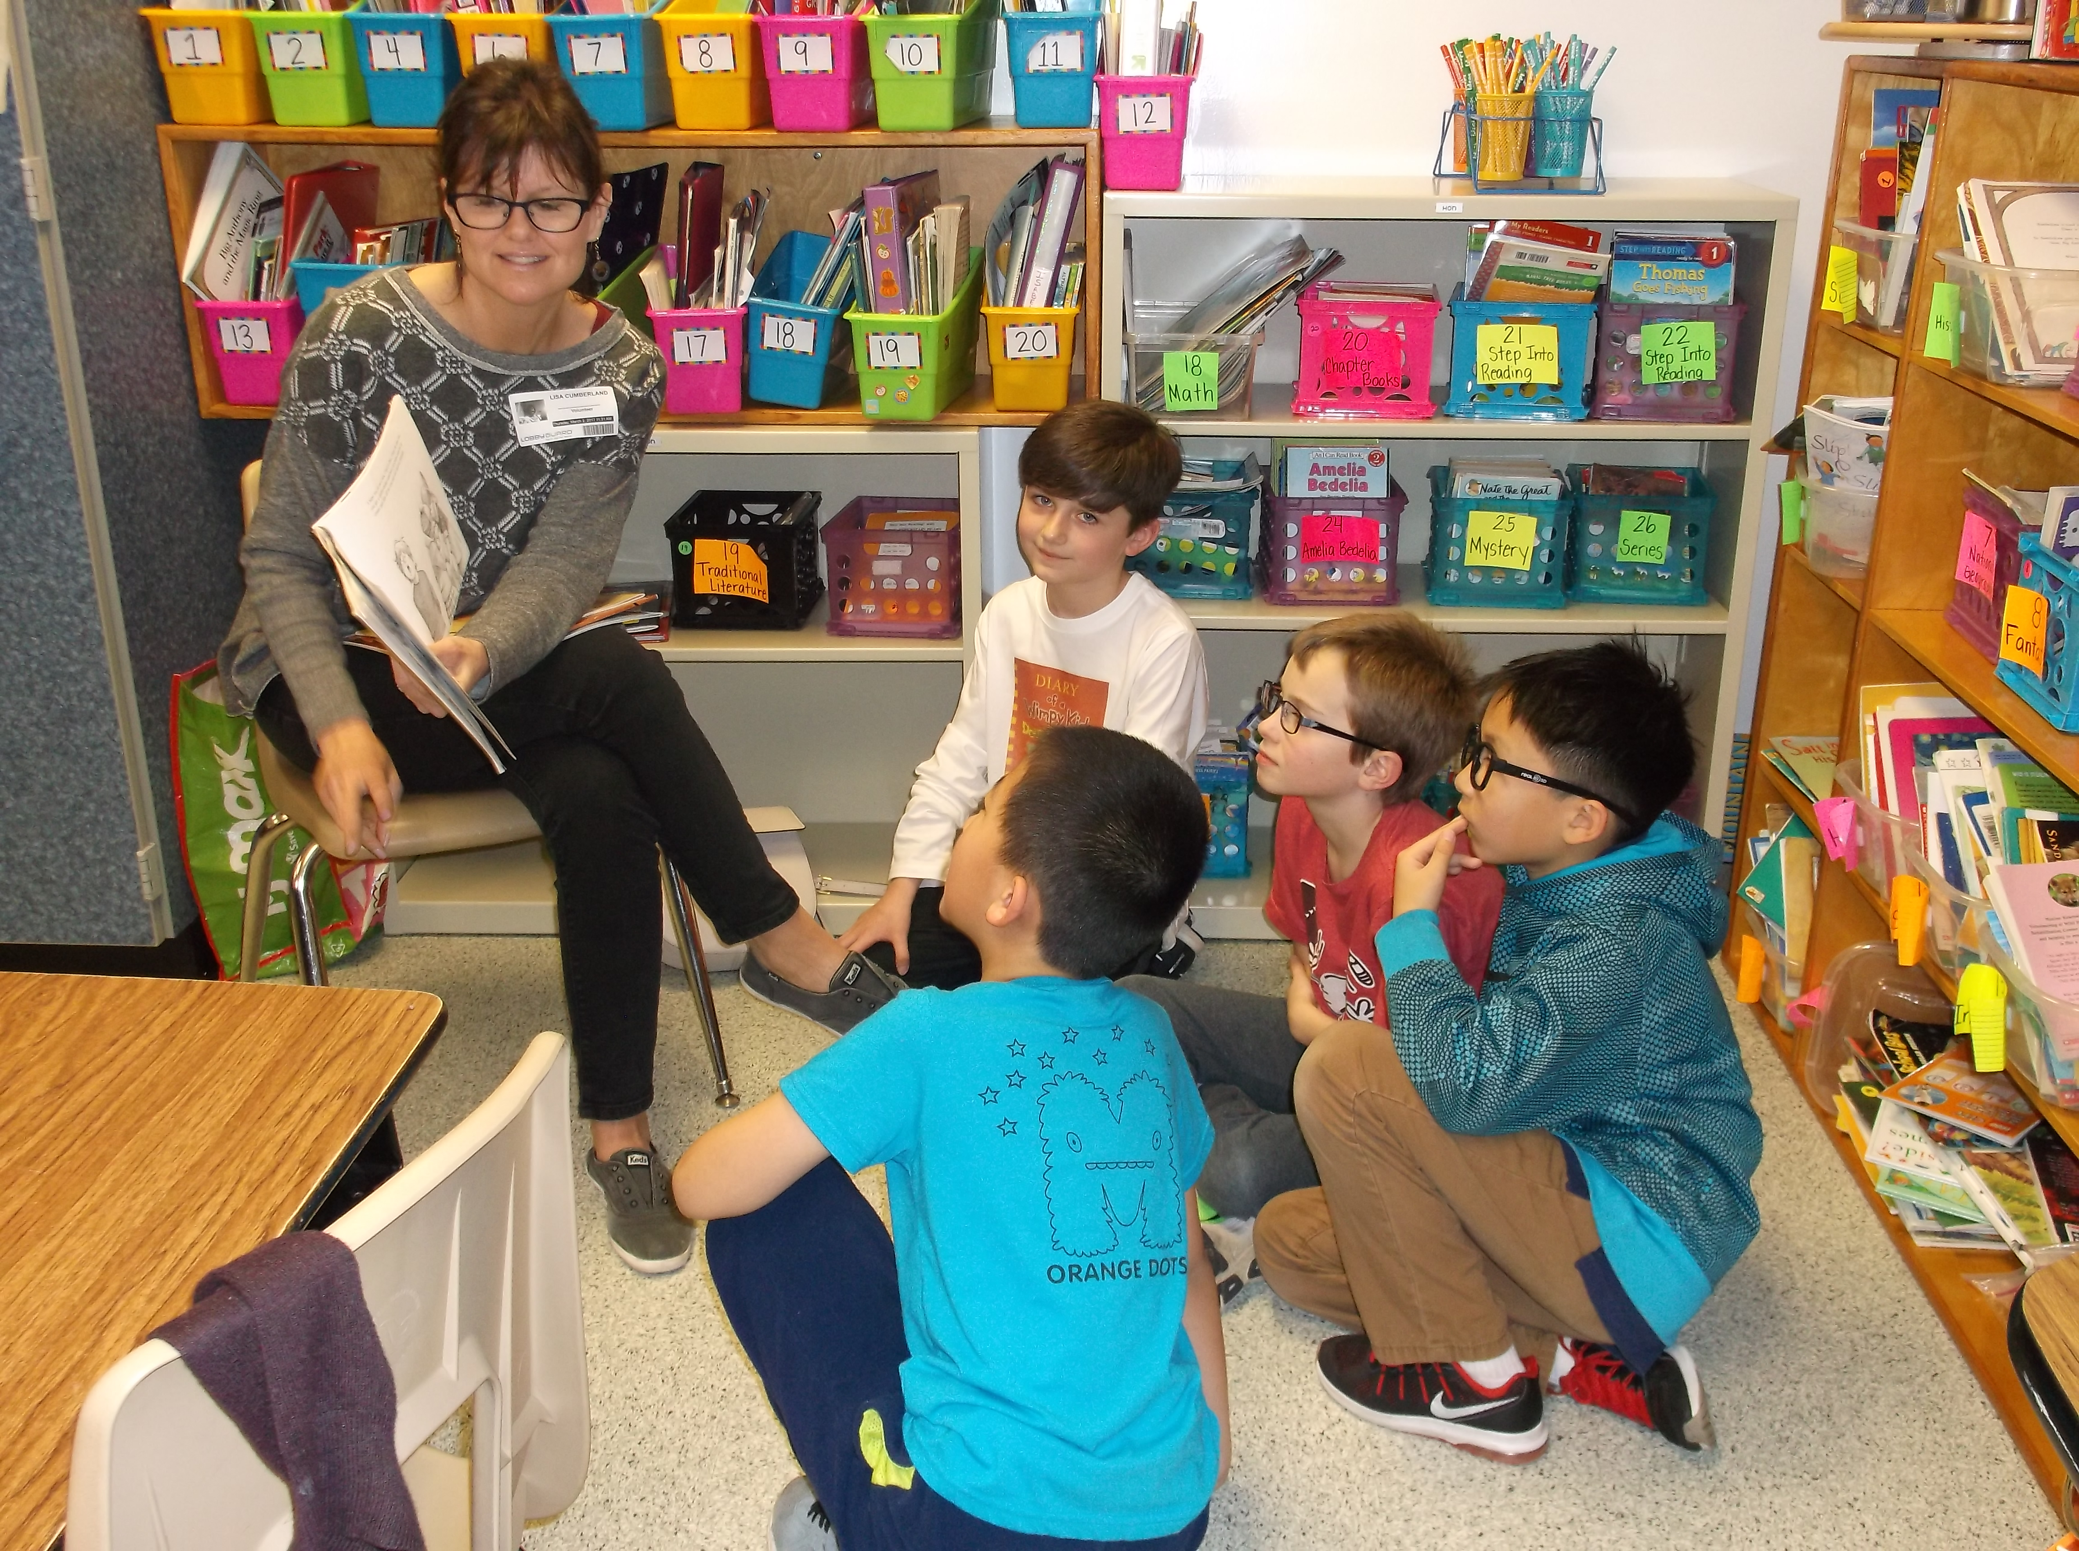
Yesterday we celebrated Dr. Seuss’s birthday. Many of our students and staff dressed as characters from their favorite Dr. Seuss books. Thank you to the parents who came in to read to our students. Many thanks to everyone who participated and made Read Across America Day so special!
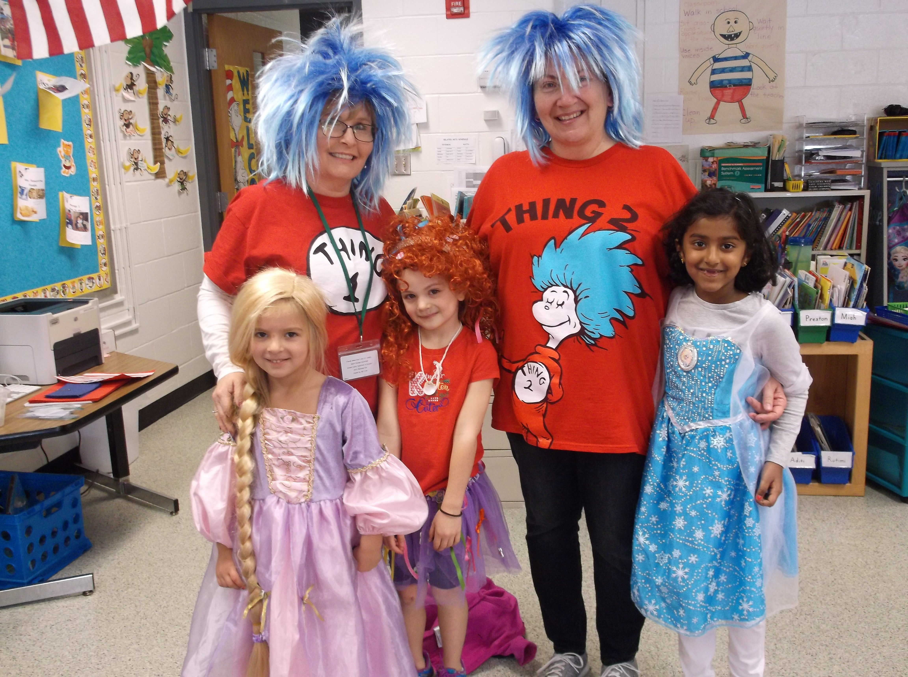

Sincerely,

Kaye M. Breon, Principal
Ann Steger, Assistant Principal
CALENDAR OF EVENTS

Wednesday, March 8 Interim Reports Issued
Thursday, March 9 Parent/Teacher Conferences – 3-Hour Early Dismissal (12:45 p.m.)
Friday, March 10 Parent/Teacher Conferences – 3-Hour Early Dismissal (12:45 p.m.)
Friday, March 10 PBIS Celebration - 9:30 to 10:30 a.m.
Thursday, March 16 PTA Meeting in Media Center – 6:30 p.m.
Friday, March 17 School Spirit “Green” Day
Monday, March 20 JA in a Day
Tuesday, March 21 Vision & Hearing Screening for Kindergarten & 1st Grade Students
Wednesday, March 22 Gr. 5 Parent Information Night (Room 123) – 5:00 p.m.
Monday, March 27 PTA Sponsored Cultural Arts Assembly, “Amazing Animals”
Wednesday, March 29 Family Reading Night – 6:00 to 7:30 p.m.
Thursday, March 30 Vision & Hearing Rescreening

SCHOOL NEWS

Dismissal Arrangements
This is a reminder that notes are needed if you want your child to follow a different dismissal arrangement. Advising a student of a dismissal change is not satisfactory. Notes must be sent to school if you wish for your child to be dismissed to Circle Drive or attend an afterschool activity. Please refrain from emailing this information. If our Internet is not working or if a teacher has a substitute, your message will not be received. The office is receiving too many last minute telephone calls and emails. Arrangements via telephone will only be honored in the event of an emergency.

WFES is proud to host its 4th Annual JA in a Day!
On March 20th, our school will participate in JA in a Day, a unique hands-on education program operated by Junior Achievement of Central Maryland. This in-classroom event encompasses important elements of community and economy, work readiness, financial literacy, and business management. At the end of the day, WFES students will have completed 5 JA sessions and will earn a JA certificate.

Hearing & Vision Screening
Hearing and Vision Screening will take place on March 21st. All Kindergarten and First Grade students will be screened that morning. We need three parent volunteers from 9:00 a.m. to 12:00 noon. Volunteers will locate students, walk them to and from the screening area, and supervise them as they wait to be screened. If you are able to help us, please contact Ms. Penny Jones at Penny_Jones@hcpss.org or 410-313-5512.

Family Reading Night
You are invited to Family Reading Night on Wednesday, March 29th, 6:00 to 7:00 p.m. WFES staff will wet your appetites with book talks and snippets of some of our favorite and greatest books in many different genres. Students will have a chance to create an “I Want to Read” wish list filled with books to check out from the school library to make reading at home the best part of you and your child’s night. Cocoa will be served to make your night of tasting complete.

In addition, Mrs. Elizabeth Burns will be offering a session on Internet safety. *If you plan to attend this session, please bring your iPad/tablet with you.

Please RSVP by March 17th. We need to know how many family members will be attending to help us have enough materials and cocoa for all. We hope to see you here!
Kindergarten Registration Continues
Do you have a child who will be 5-years old by September 1, 2017? Every child who is 5 years old by September 1 must be enrolled in kindergarten this fall or have an approved waiver. Kindergarten Registration is underway! Please contact Mrs. Colleen Green at 410-313-5512 or colleen_green@hcpss.org to schedule an appointment. Please visit http://www.hcpss.org/enroll/ for additional information.
Students must be registered by a custodial parent (biological, adoptive, legal guardian), and the parent must live within the school attendance area. Please be prepared to spend about 30-minutes completing paperwork. The following documents are required at time of registration:
- Parent picture ID: original driver’s license, military ID, or passport.
- Signed original, current lease or deed with your address, valid dates, signatures.
- Current utility bill with name and address (non-cellular telephone, gas and electric, cable bill).
- Student’s proof of birth (original birth certificate, passport/visa, physician’s certificate, baptismal or church certificate, parent’s affidavit or birth registration).
- Proof of parental relationship, custody, or guardianship. If applicable, bring legal proof of custody (court order).
- Student’s current proof of immunizations signed by a doctor, health care provider, day care provider or school official.
- Documentation of Special Education (IEP), 504, Psychological Report, or related services.
- Any additional paperwork that may be necessary due to special living arrangements or circumstances.
Please contact Mrs. Colleen Green at 410-313-5512 or colleen_green@hcpss.org to schedule an appointment. Please visit http://www.hcpss.org/enroll/ for additional information.

STEM DAY
On May 10, 2017 WFES will be having our annual STEM Day. As always, we would love to involve you, the parents on this fun day for students! The students love your hands on informative activities! If this sounds like something you would like to participate in, please contact Ms. Lauren Watts at lauren_watts@hcpss.org and let her know what grade level you would be interested in presenting to and what ideas you have in mind. Our goal is to have at least two presenters for each grade in the areas of science, technology, engineering, and/or math. Please let us know by April 20th so we can ensure that we have enough volunteers. We are looking forward to a great day!

Home & School Connection
Please view the attachment to read the March issue of Home & School Connection. This publication is available in both, English and Spanish.

PTA NEWS The next PTA Meeting is Thurday, March 16 at 6:30 p.m.
Come, Join Us!
The PTA has started planning for next year and we have executive board positions and committee head positions that will need to be filled. If you are interested in getting more involved in the PTA and helping our staff, students, and community have a great year, we would love to hear from you!

Please contact a member of the nominating committee:
Hina Naseem at hnaseem@mac.com
Penny Jones at penny_jones@hcpss.org
Kathy Baur at kdbaur@gmail.com
Restaurant Fundraiser
When you dine at Glory Days Grill (Ellicott City or Eldersburg locations) now through June 2, 2017, the restaurant will contribute 10% of your total food and beverage purchases to West Friendship Elementary School. Please share this information with your neighbors, friends, and relatives, because the 10% applies to the total food and beverage bill. Simply ask your server for your itemized original receipt and send it to school with your child addressed ATTENTION: PTA/Jen Lowther/Glory Days. Questions? Please mail Jen @ jlowther4@gmail.com.

Checkmate, Mates! Chess Club at WFES
WFES PTA is happy to partner with Silver Knights Chess players and educators to offer a Chess Club at our school. The weekly sessions, beginning in April, will be a mix of learning and play.

Research shows that chess can dramatically improve elementary students’ levels of concentration, boost problem-solving skills and develop their thought processes. It is also believed that chess can boost mathematical literacy levels with amazing benefits across other subjects, including reading — all while having fun!

The WFES Chess Club will be taught by experienced trainers using a curriculum developed by National Masters. Silver Knights also has a need-based scholarship program to help children participate in their program. Classes will be held on Fridays, April 21st to June 9th at 4:00 pm-5:00 pm, except May 19th (school closed for a professional day). The cost for the 7-week session is $98. Find out more at: www.skenrichment.com. You can register your child online at:
https://skenrichment.com/clubs/howard/product/3989-west-friendship-elementary-school-spring-2017.html. Flyers were sent home last week, and registration ends on April 14th.

Spirit Wear Online Store
Both the t-shirts and the hoodies are available to be purchased online at the WFES PTA website: www.wfespta.com/shop. We have all sizes -- all the way from youth small to adult 3XL!
Order online today and The WFES PTA will send them home promptly via backpack mail.
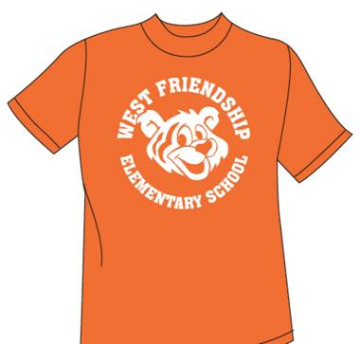

COMMUNITY NEWS
Smokin’ Hot Restaurant Fundraiser!!
Join us Monday, March 6th to support The Glenelg Marching Unit! Smokin’ Hot fundraiser will be happening all day on the 6th, come in anytime. This is valid for dine-in or carry out. The flyer must be presented at the time of payment in order to receive the donation. Go to the Glenelg Band website or to the Glenelg Band Facebook page to find a link for the flyer.

* Smokin’ Hot Grille * 2465 MD-97 * Glenwood, MD 21738 * 410-489-6001 *

Learning Together Program
Bushy Park Regional Early Childhood Center-Preschool/Pre-Kindergarten
The Bushy Park Regional Early Childhood Center (RECC) preschool and pre-kindergarten programs are now accepting applications for classes for the 2017/18 school year. These classes include children with and without disabilities. The program’s focus is helping all children develop communication, literacy, math, problem solving, motor, and social skills. Parents of children who will be 3-years old by September 1, 2017 or 4-years of age may contact Katie Hereth in the school office for an application package beginning mid-February.

All applications must be returned by the last Friday in March. A limited number of openings are available for children without disabilities. Children are selected based upon screening information given on the application form and the “Ages and Stages Questionnaire,” as well as observations of the child’s participation in a playgroup on April 7, 2017 from 10-10:30 a.m. If necessary, a lottery process is conducted. If you have any questions, please contact Katie Hereth at (410) 442-2448 or (410) 313-5500.

Columbia Gives Annual Bingo!
Mark your calendar for Friday, April 28th. Columbia Gives Annual Bingo will be held at Wilde Lake High School in the cafeteria. Enjoy an evening of fun bingo, silent auction, raffles and door prizes! The doors open at 5:45 and bingo begins at 6:45 p.m. Tickets are $20 in advance and $25 at the door. Proceeds benefit local community resources, including HCPSS’s Pupil Personnel Workers’ Fund, food banks, Grassroots, etc. Please call Long & Foster Columbia for tickets, 410-730-3456. Dinner and dessert will be available for purchase. Canned goods will be collected for the Howard County Food Bank.

Howard County Public Library – Glenwood Branch
The following presentations require registration (which begins one week prior to class). Please register by phone (410-313-5579) or on-line, www.hclibrary.org.

Discovering Great Artists: Georgia O'Keefe
Date: Thursday, March 9, 2017
Time: 3:00 PM - 3:45 PM
Branch: Glenwood Branch
Description: Learn about the life and methods of history's greatest artists, then use their techniques to create a piece of art.
Ages 7-10; 45-minutes (Howard County schools close early)

Terrific Trolls
Date: Friday, March 10, 2017
Time: 3:00 PM - 3:45 PM
Branch: Glenwood Branch
Description: Enjoy stories and a song, then create a troll.
Ages 5-9; 45-minutes (Howard County schools close early)

Build & Create Workshop
Date: Saturday, March 11, 2017
Time: 3:30 PM - 4:30 PM
Branch: Glenwood Branch
Description: Explore unique STEM building materials and recycled objects to design and build a creative masterpiece.
Ages 9-12; Allow 30-minutes

3D Art Lab
Date: Monday, March 13, 2017
Time: 4:30 PM - 5:30 PM
Branch: Glenwood Branch
Description: Create an open-ended art project that pops out, stands up, swings from the ceiling, or makes you walk around it.
Ages 9-11; 60-minutes

Chemistry in the Library: Chemistry Helps Feed the World
Date: Saturday, March 18, 2017
Time: 11:00 AM - 12:00 PM
Branch: Glenwood Branch
Description: Join a chemist from the Army Research Laboratory and the American Chemical Society for hands-on experiments exploring topics on agriculture including the chemistry of fertilizers.
Ages 7 & up (7-8 year olds must be accompanied by an adult); 60-minutes

Celestial Searchers Young Astronomers Club
Date: Monday, March 27, 2017
Time: 7:00 PM - 8:00 PM
Branch: Glenwood Branch
Description: Local astronomy educator Dr. Joel Goodman discusses our solar system and beyond with fun and engaging hands-on activities. Explore a different astronomy theme each month.
Ages 5-14; with adult; 60-minutes No registration required.

National Crayon Day
Date: Thursday, March 30, 2017
Time: 4:30 PM - 5:15 PM
Branch: Glenwood Branch
Description: Celebrate more than a century of colorful expression with stories, facts, and a craft.
Ages 5-8, 45-minutes

National Crayon Day
Date: Thursday, March 30, 2017
Time: 7:00 PM - 7:45 PM
Branch: Glenwood Branch
Description: Celebrate more than a century of colorful expression with stories, facts, and a craft.
Ages 5-8, 45-minutes

